Visual Studio 2019 Fixes

# Error 1: xx_log.ldf Already Exists

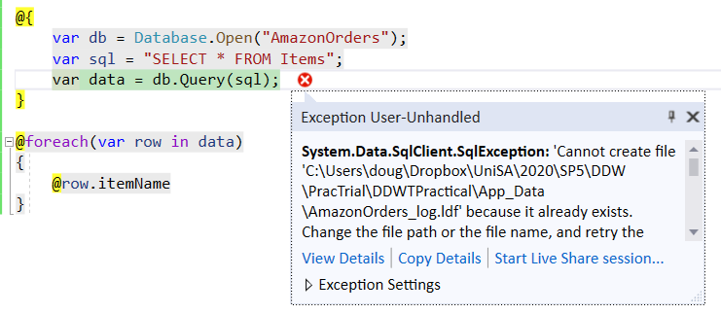**Example Error Message**

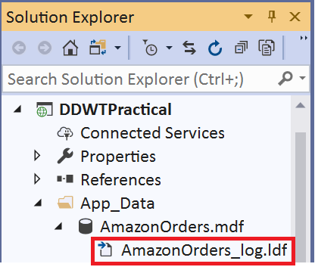**Solution:**

In the **Solution Explorer**

> expand the **App_Data** folder

> expand the **AmazonOrders** database file

> delete the xx_log.ldf file

> re-run the application

# Error 2: Value Length for key greater than 128 characters

**Example Error Message:**

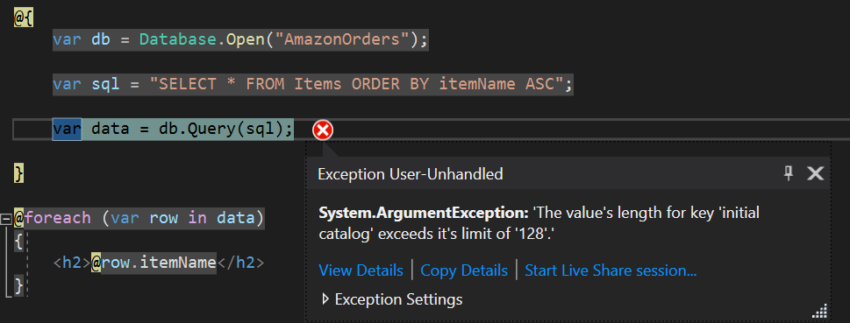

**Solution:**

This is because the file path containing your Web Application project is to long (ie nested in to many folders).

1. Move the web application to a folder closer to the main HDD drive you are using (ie, not nested in say Documents/Uni/2020/Sp5/INFS1025 Data Driven Web Tech/Practicals/W11 but something shorter like Documents/Uni/2020)
2. Alternatively, you can create a relative connection string in the **web.config** file using the “Fix 1: Obtaining a Connection String using the VS2019 Server Explorer” instructions on the next pages.

# Error 3: Network Instance Error

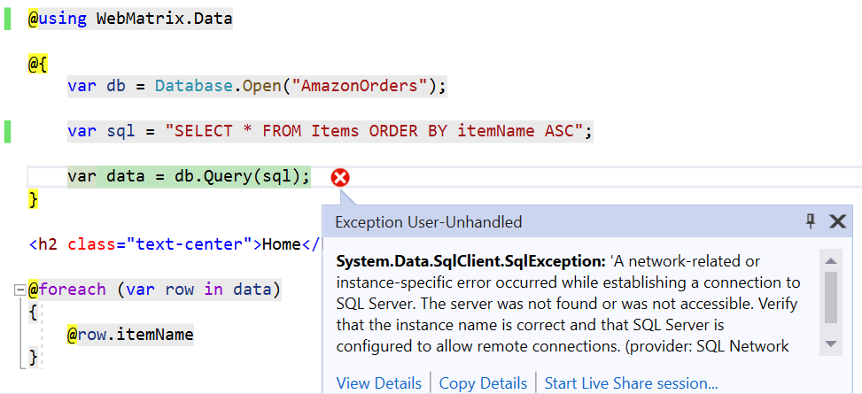Generally this error is caused by the SQL Server not being available. Common causes:

1. The SQL Server service is not running
2. The SQL Server Connection is incorrect

**Solution:**

1. In the **Solution Explorer** Expand the **App_Data** folder to show the Database
2. **Double Click** on the database to open it in the **Server Explorer** window.
3. In the **Server Explorer** window check that you can expand the database and expand the **Tables** folder
4. Check that you can view the columns in a Table.
5. Assuming this works, try running the web application again

**Next Steps**

If the above steps did not resolve the issue, a different connection to the database is needed.

## Fix 1: Obtaining a Connection String using the VS2019 Server Explorer

Note: these steps can also be used to overcome the 128 character limit issue when using Database.Open(“xx”);

**Using the above steps, if you are able to successfully view the database using the server explorer window in VS2019 then you can use the server explorer as the source of your database connection string:**

1. Right click on the **AmazonOrders** database in the **Server Explorer window**
2. > Select **Properties** to view the connection string details as shown below
3. > click in the box to the right of the **connection string** setting and use   
   Ctrl + A to highlight the string then   
   Ctrl + c to copy

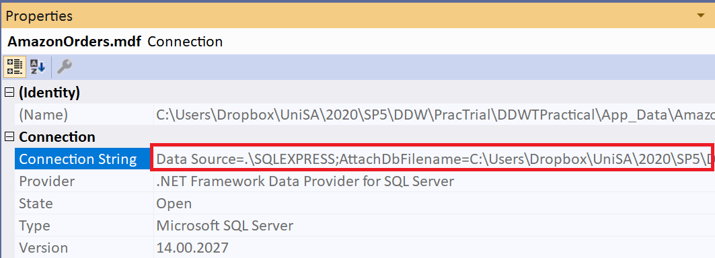

1. In the **Solution Explorer** open the **Web.config** file in the **Root Directory** of the DDWTPractical project (found down the bottom of the solution explorer window).
2. Nested in the **configuration** element, add a new **connectionStrings** tag as shown below, along with the **add** element tag. **Paste** the connection string you copied above as the **connectionString** value to the add tag.

Add this new entry

<configuration>

**<connectionStrings>**

<add name="AmazonOrders"

connectionString="[**paste your copied connection string here**]"

providerName="System.Data.SqlClient"/>

**</connectionStrings>**

<appSettings>

<add key="webpages:Version" value="3.0.0.0" />

<add key="webpages:Enabled" value="false" />

<add key="ClientValidationEnabled" value="true" />

<add key="UnobtrusiveJavaScriptEnabled" value="true" />

</appSettings>

...etc

1. Example pasted connection string (don’t copy this as your server name + file path will be different):



1. This connection string contains the **absolute** location of the database (shown in blue below) – if you move the application to a different folder on your hard drive the connection will break. The next step is to modify the string so that it is **relative** to the application folder. Modify the **AttachDbFilename=xx** section of the connection string as below to reference the **App_Data** folder:

<add name="AmazonOrders"

connectionString="Data Source=.\SQLEXPRESS;AttachDbFilename=C:\Users\Dropbox\UniSA\2020\SP5\DDW\PracTrial\DDWTPractical\App_Data\AmazonOrders.mdf;Integrated Security=True;User Instance=True"   
 providerName="System.Data.SqlClient"/>

<add name="AmazonOrders"

connectionString="Data Source=.\SQLEXPRESS;AttachDbFilename=|DataDirectory|\AmazonOrders.mdf;Integrated Security=True;User Instance=True"

providerName="System.Data.SqlClient"/>

1. Save your changes to the **web.config** file then return to your HTML view file and run the application.

## Fix 2: Changing the Default Server in Visual Studio

If you are unable to view the database in your **App_Data** folder using the **Server Explorer** window in Visual Studio, then you need to fix the default settings used by Visual Studio.

1. Open your **SQL Server Management Studio** application and connect to the **SQL Server** you have been using throughout the semester. Make sure it connects and that you can view databases and tables because you need to know the server is working **before** copying the link.
2. Locate the **name** of the SQL Server instance that is working (highlighted in red below). You can right click on the Server in the Server Explorer > **Properties** > Name and copy the name AFTER the “\” if necessary.

> The example server below is called **SQLEXPRESS**

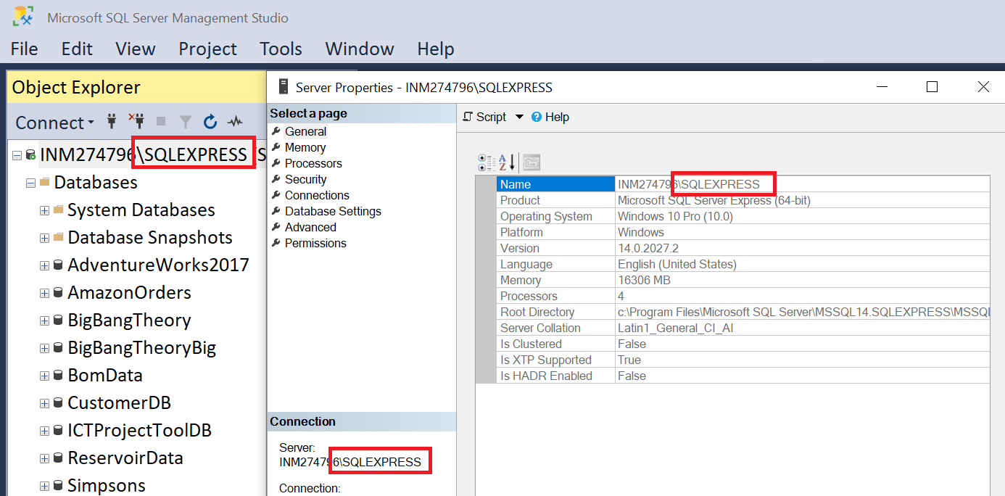

1. In Visual Studio, click **Tools** in the top level menu  
   > **Options**> **Database Tools**

> **Data Connections**

1. Update the Data Connections value to match your available server name. Then close and restart Visual Studio for the setting changes to take place. You will then need to test your ability to open the database in the App_Data folder by double clicking on it again:

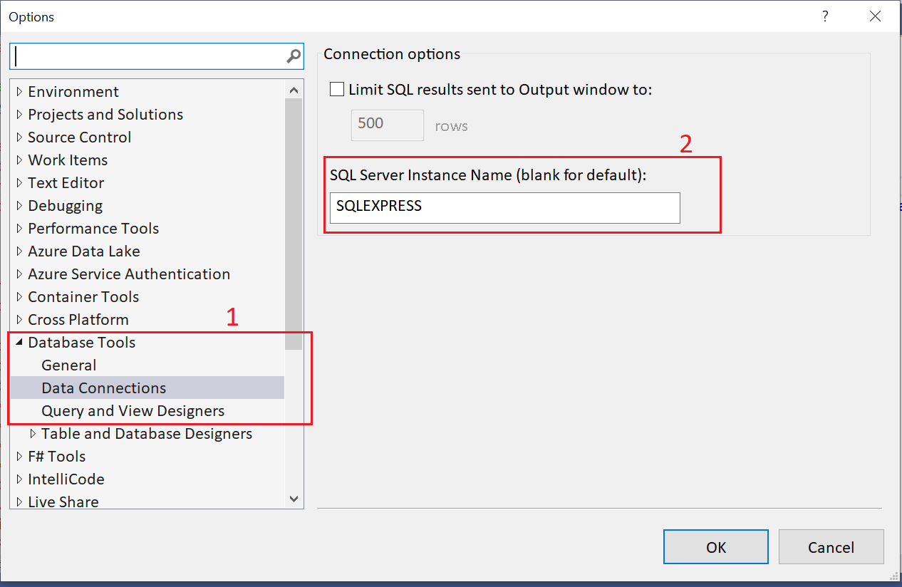

ERROR 26 - Error Locating Server/Instance Specified)

1) Make sure your server name is correct, e.g., no typo on the name.

2) Make sure your instance name is correct and there is actually such an instance on your target machine. [Update: Some application converts \ to . If you are not sure about your application, please try both ServerInstance and Server\Instance in your connection string ]

3) Make sure the server machine is reachable, e.g, DNS can be resolve correctly, you are able to ping the server (not always true).

4) Make sure SQL Browser service is running on the server.

5) If firewall is enabled on the server, you need to put sqlbrowser.exe and/or UDP port 1434 into exception.

ERROR WEB CONFIG

<connectionStrings>

<add name="AmazonOrders"

connectionString="Data Source=(LocalDB)\MSSQLLocalDB;AttachDbFilename=|DataDirectory|\AmazonOrders.mdf;Integrated Security=True;"

providerName="System.Data.SqlClient"/>

</connectionStrings>